What are the three main characteristics of agile software development? In
What ways does agile software development differ from other software
development approaches?

https://www.educba.com/agile-characteristics/
https://www.geeksforgeeks.org/difference-between-traditional-and-agile-software-development/

An Agile team is working on improving the SLA for level-1 tickets in the production support system of an e-commerce site. Currently, Level-1 tickets take approximately 6 weeks to deploy in production.
Q.1.1 Determine two lean software development approaches that the team can
employ to improve the process.
Q.1.2 Briefly describe the steps involved in both approaches

M4
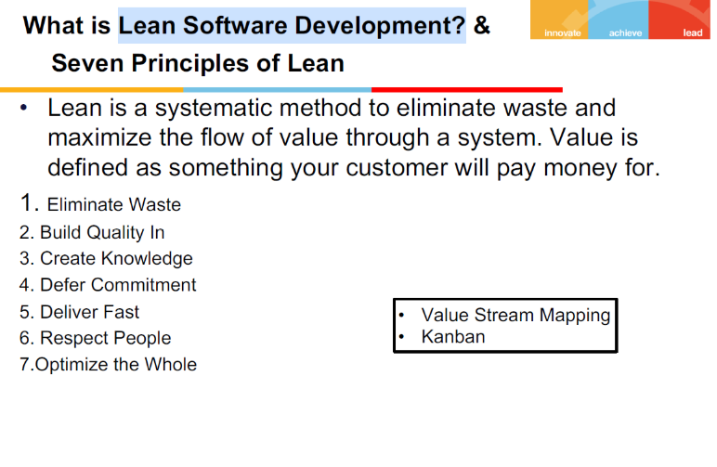
- Value stream mapping
- Kanban

https://www.plutora.com/blog/value-stream-mapping

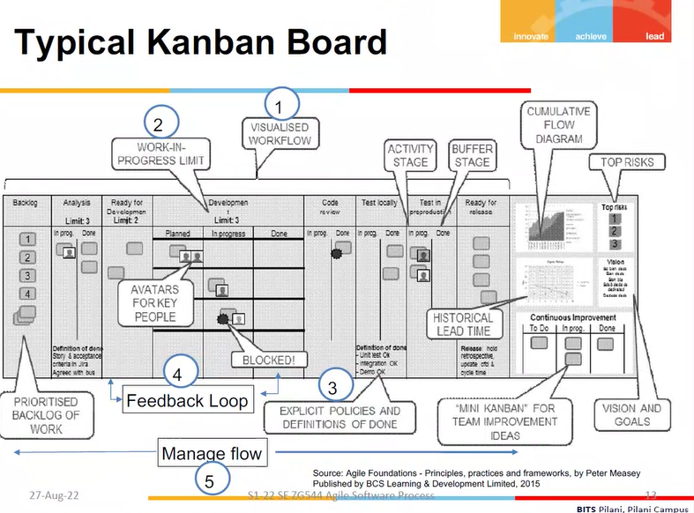

A team consists of two business analysts, four developers, and three testers.
Business Request, Scheduled, Building, Testing, Business Review, Ready for Release
are the process steps for delivering work items. [2+3+1]
Q.1.1 Create a visual representation of this workflow
Q.1.2 After a few weeks of implementing Kanban, you discovered that there are ten
work items in the testing phase and one in the business review phase. This
situation has been going on for a month. What could be the problem, and what
can you do to solve it?
Q.1.3 To begin, what WIP limit will you set?

TDD- solving problem
https://learn.microsoft.com/en-us/azure/devops/boards/boards/wip-limits?view=azure-devops#determine-initial-wip-limits

Here are the velocities of two teams working on the same type of project in nearly
identical environments and with nearly identical resourcesIteration 1 2 3 4 5 6 7

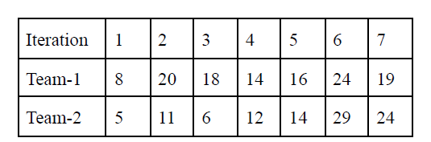
Consider team-1's iteration-1 velocity as an outlier. Determine the velocity of
team-1. Calculate team 2's velocity using "yesterday's weather" and only the last two
sprints. Which team is the most productive? What are some of the possible causes for
Team 1's velocity to drop to 10 on the next sprint?
Answer
Team 2 is productive
And team 1 raised risk factor (with some technical blocking)
Team 1: avg velocity is average of all iteration expect first as they mentioned as it is outlier
Team 2: consider last 2 sprints and find the avg
Though we calculate it, we should not compare 2 teams with avg velocity. So answer is cannot be determined

https://www.sealights.io/sprint-velocity/scrum-velocity-5-things-that-can-go-wrong/

What Can Go Wrong with Scrum Velocity?

Antipattern #1: Setting Targets for Velocity
Agile velocity is meant to be an empirical measure of a team’s progress, which can be used for estimation—not a goal or metric by which team performance is measured.
Setting velocity targets can be misleading, because Scrum story point estimates are subjective. Giving a team a goal of 30 story points per sprint might be meaningless, because the team can subjectively define what scope of work 30 story points actually means.
At the same time, velocity is something that is within a Scrum team’s control, and it is a variable of prime concern to management. Velocity must be upheld and improved over time as teams improve the Scrum process, adopt new tooling, and become more proficient.
Bottom line: R&D managers can aim to improve velocity. However, this should be done by helping teams improve processes and remove obstacles, not by setting a quantitative velocity goal.

Antipattern #2: Expecting Instantaneous Maximum Velocity
New Scrum teams, existing teams starting a new project or switching to a different type of work, all must go through several iterations before they get into a rhythm. The team needs to learn how to cooperate and distribute work between team members, understand the complexity of tasks within the sprint plan, and adapt to outside dependencies and requirements.
Additionally, at the outset, Scrum teams and managers will not be able to accurately estimate velocity. The premise of Scrum is that only after you “get your hands dirty,” build software and bring it to production readiness, do you really understand the full process and the complexity inherent in the work.
Bottom line: Wait for Scrum teams to mature and realize their full potential before estimating velocity.

Antipattern #3: Work Not Broken Down into Granular Pieces
An essential component of Scrum is working on small pieces of work that are easy to understand, scope and estimate. Software projects are broken down into epics, sprints, user stories and tasks, and team members churn through one task at a time.
The problem starts when teams don’t break down items with sufficient granularity. For example, a user story is defined as a large effort that might take a week to develop by several team members. A symptom of this problem is that the burndown chart drops sharply in the middle of a sprint. This can be a root cause of erratic or decreasing velocity from sprint to sprint.
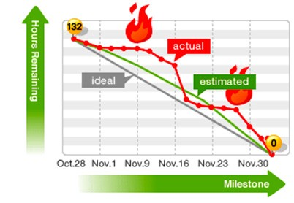
Bottom line: Break down work into small pieces to make planning simpler and velocity more predictable.

Antipattern #4: No Slack
To be effective, a Scrum team needs some “slack” or idle time built into its sprints. A common rule of thumb is to plan for 20% slack for ongoing communication, teammates to pair and solve problems, and addressing urgent issues or interruptions.
Planning sprints with no slack in order to increase velocity will probably only decrease it. Team members will focus on completing their tasks and adopt an “I am busy” attitude; something which over time erodes the team’s cooperation and problem solving abilities. To be agile, a Scrum team needs some shoulder room.
Bottom line: Teams with no slack time become “busy” and overly focused on individual objectives, hurting their velocity in the long term.

Antipattern #5: Testing, Technical Debt and Known Bugs
One of the biggest fallacies in estimating velocity is that the output of a sprint only consists of new features delivered to the customer. Virtually every sprint will also contain:
- Time to build and maintain automated tests
- Time to respond to test results and fixed bugs
- Previous known bugs
- Technical debt from previous sprints
While these things do not add new functionality a user can play with, they do add tangible value for end users in the form of higher quality. Management must allocate some of the resources of their Scrum teams (often a large portion) to these additional elements. Otherwise, software quality will deteriorate and make things much more difficult in future sprints.
Bottom line: Without an investment in quality, users suffer and projects move slower in the long run.

Here are some excerpts from user stories. Using Story points, size them
appropriately. Your assumptions should be listed.
1. Migrate a legacy datastore to a new database technology.
2. Add a text field to the form.
3. User Id validation and storage to the form.
4. Data is retrieved using a third-party API that has been integrated.
5. Redesign a web application's layout
6. Migrate from a complex form to a new form in stages.
The team's velocity over the last three iterations has been: 20,25,28 story
points. How long will it take the team to complete the first four stories?

24
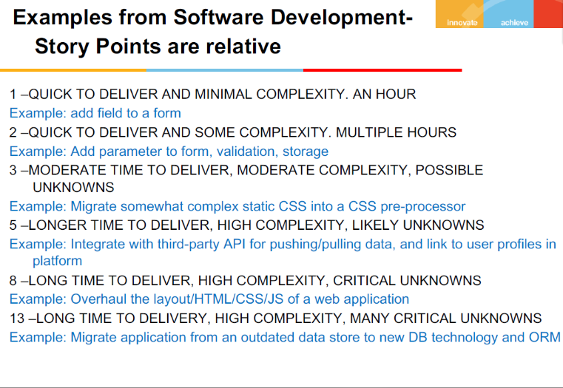

In their most recent two-week iteration, Team-A completed 43 story points.
Team-B is working on a different project and has twice the number of developers as
Team A. In their most recent two-week iteration, they also completed 43 story points.
How is that possible?
Can we conclude that Team A is more productive than Team B?
Possible – env is different, technology skills is different, estimation process is different for team a and b
Underestimate/overestimate project
Team B is more productive

Q.7 Set. (A)
Q.1.1 During an estimating meeting five programmers are estimating a story.
Individually they estimate the story at two, four and five story points. Which
estimate should they use? [2]
Q.1.2 A group of people is gathering to estimate user stories and arrange them on
the wall according to their size. What method is the team attempting to employ?
What is the goal/purpose of this technique?

Planning Poker
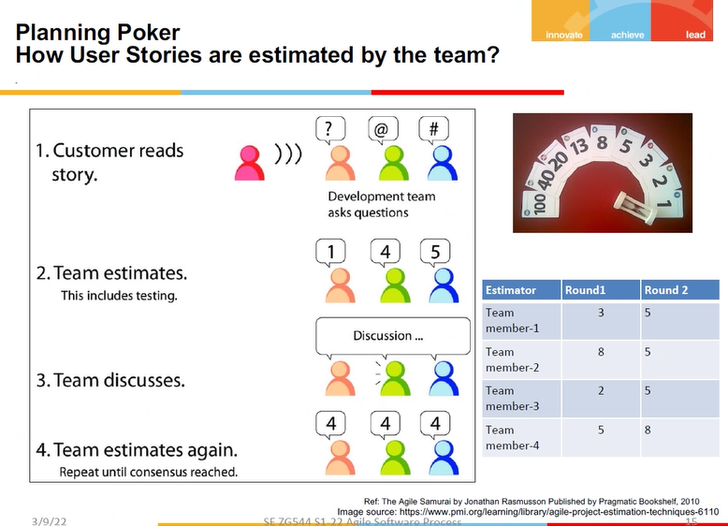

Q.1.2 A group of people is gathering to estimate user stories and arrange them on
the wall according to their size. What method is the team attempting to employ?
What is the goal/purpose of this technique?

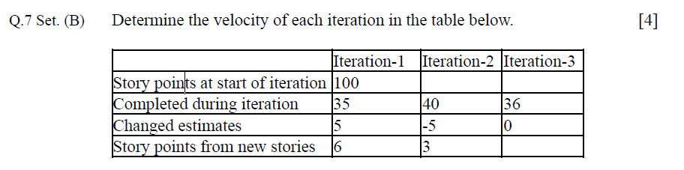

35, 40, 36
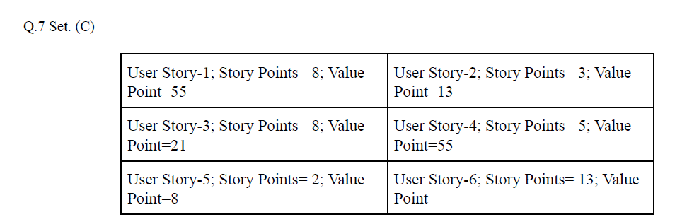
The team velocity is 13 and the iteration length is 2 weeks. Which user stories will be
targeted for the next iteration? The customer desired that releases be made after every
Page 4
second iteration. This project begins on March 15, 22? What is the anticipated
deadline for the final release?
Answer:

Total story points = 8+5+8+3+2+13=39
Velocity= 13 stories per 2 weeks
Therefore 39 stories takes 6 weeks
Eg - (39/13)*2 = 6 weeks
So from 15 Mar 22, 06 weeks is 25 Apr 22

